**Ideation Phase**

**Cafeteria Menu Display Template**

|  |  |
| --- | --- |
| Date | 28 June 2025 |
| Team ID | LTVIP2025TMID30350 |
| Project Name | Cafeteria Menu Display |
| Maximum Marks | 4 Marks |

**Cafeteria Menu Display Template:**

Cafeteria menus are more than just a list of meals—they’re a daily opportunity to share delicious options, promote healthy choices, and add a bit of excitement to mealtime. Use this template to present your menu in a clear, attractive way that helps everyone see what's cooking—whether you're in a school, office, or community setting.

Prioritize clarity and variety, highlight special options, and don’t forget to celebrate the little extras that make the dining experience enjoyable. Use this layout for print, screens, or digital boards—even if you’re not serving in the same room!

Reference:[**https://kb.bindolabs.com/dashboard-articles/managing-menu-builder-on-dash board**](https://kb.bindolabs.com/dashboard-articles/managing-menu-builder-on-dashboard)

[**Step-1: Team**](https://www.mural.co/templates/brainstorm-and-idea-prioritization) **Planning & Define the Menu Display Goal**

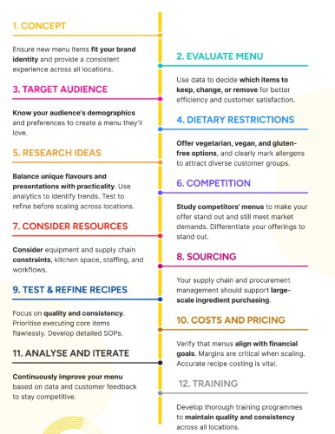

# Step-2:Menu Planning, Dish Listing, and Category Grouping

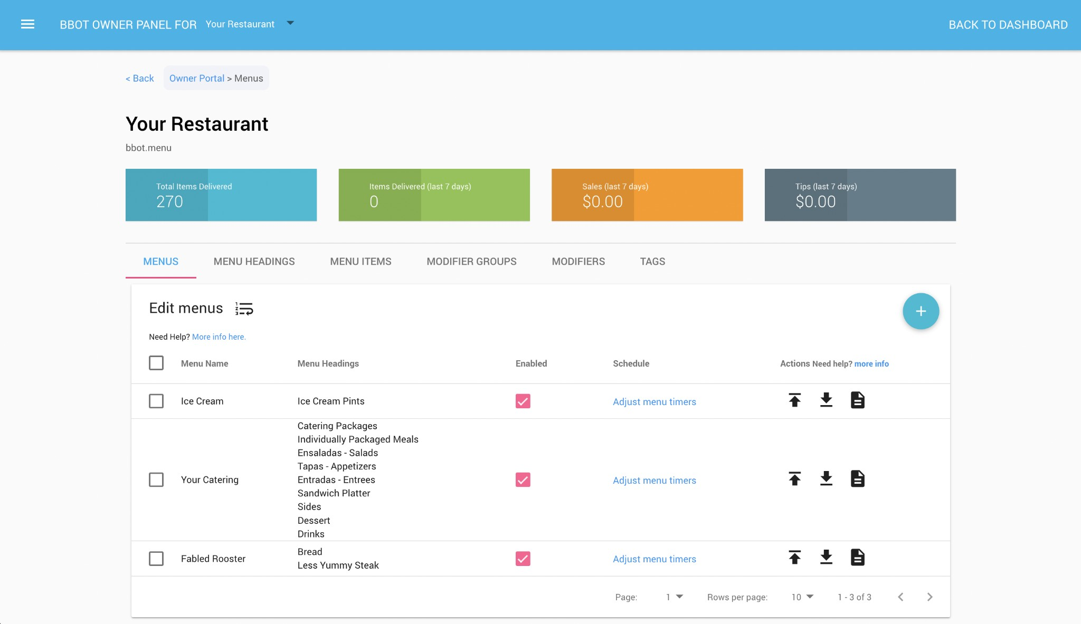

# Step-3: Menu Item Selection and Prioritization

